主题：学习动机

题型：柱状图

The charts below show the main reasons for study among students of different groups and the amount of support they received from employers.

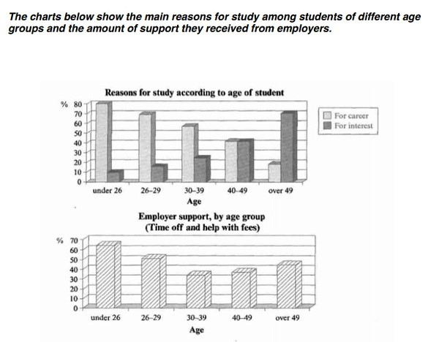

范文：

The bar charts compare students of different ages in terms of why they are studying and whether they are supported by an employer.

It is clear that the proportion of students who study for career purposes is far higher among the younger age groups, while the oldest students are more likely to study for interest. Employer support is more commonly given to younger students.

Around 80% of students aged under 26 study to further their careers, whereas only 10% study purely out of interest. The gap between these two proportions narrows as students get older, and the figures for those in their forties are the same, at about 40%. Students aged over 49 overwhelmingly study for interest (70%) rather than for professional reasons (less than 20%).

Just over 60% of students aged under 26 are supported by their employers. By contrast, the 30-39 age group is the most self-sufficient, with only 30% being given time off and help with fees. The figures rise slightly for students in their forties and for those aged 50 or more.